# Installing LoopStructural QGIS plugin

## Requirements

* QGIS >3.28
* Python dependencies
  + LoopStructural
  + Loopstructuralvisualisation
  + Pyvistaqt
  + Geoh5py

## Install python dependencies

Open OSGeo4W.bat to access the QGIS python environment

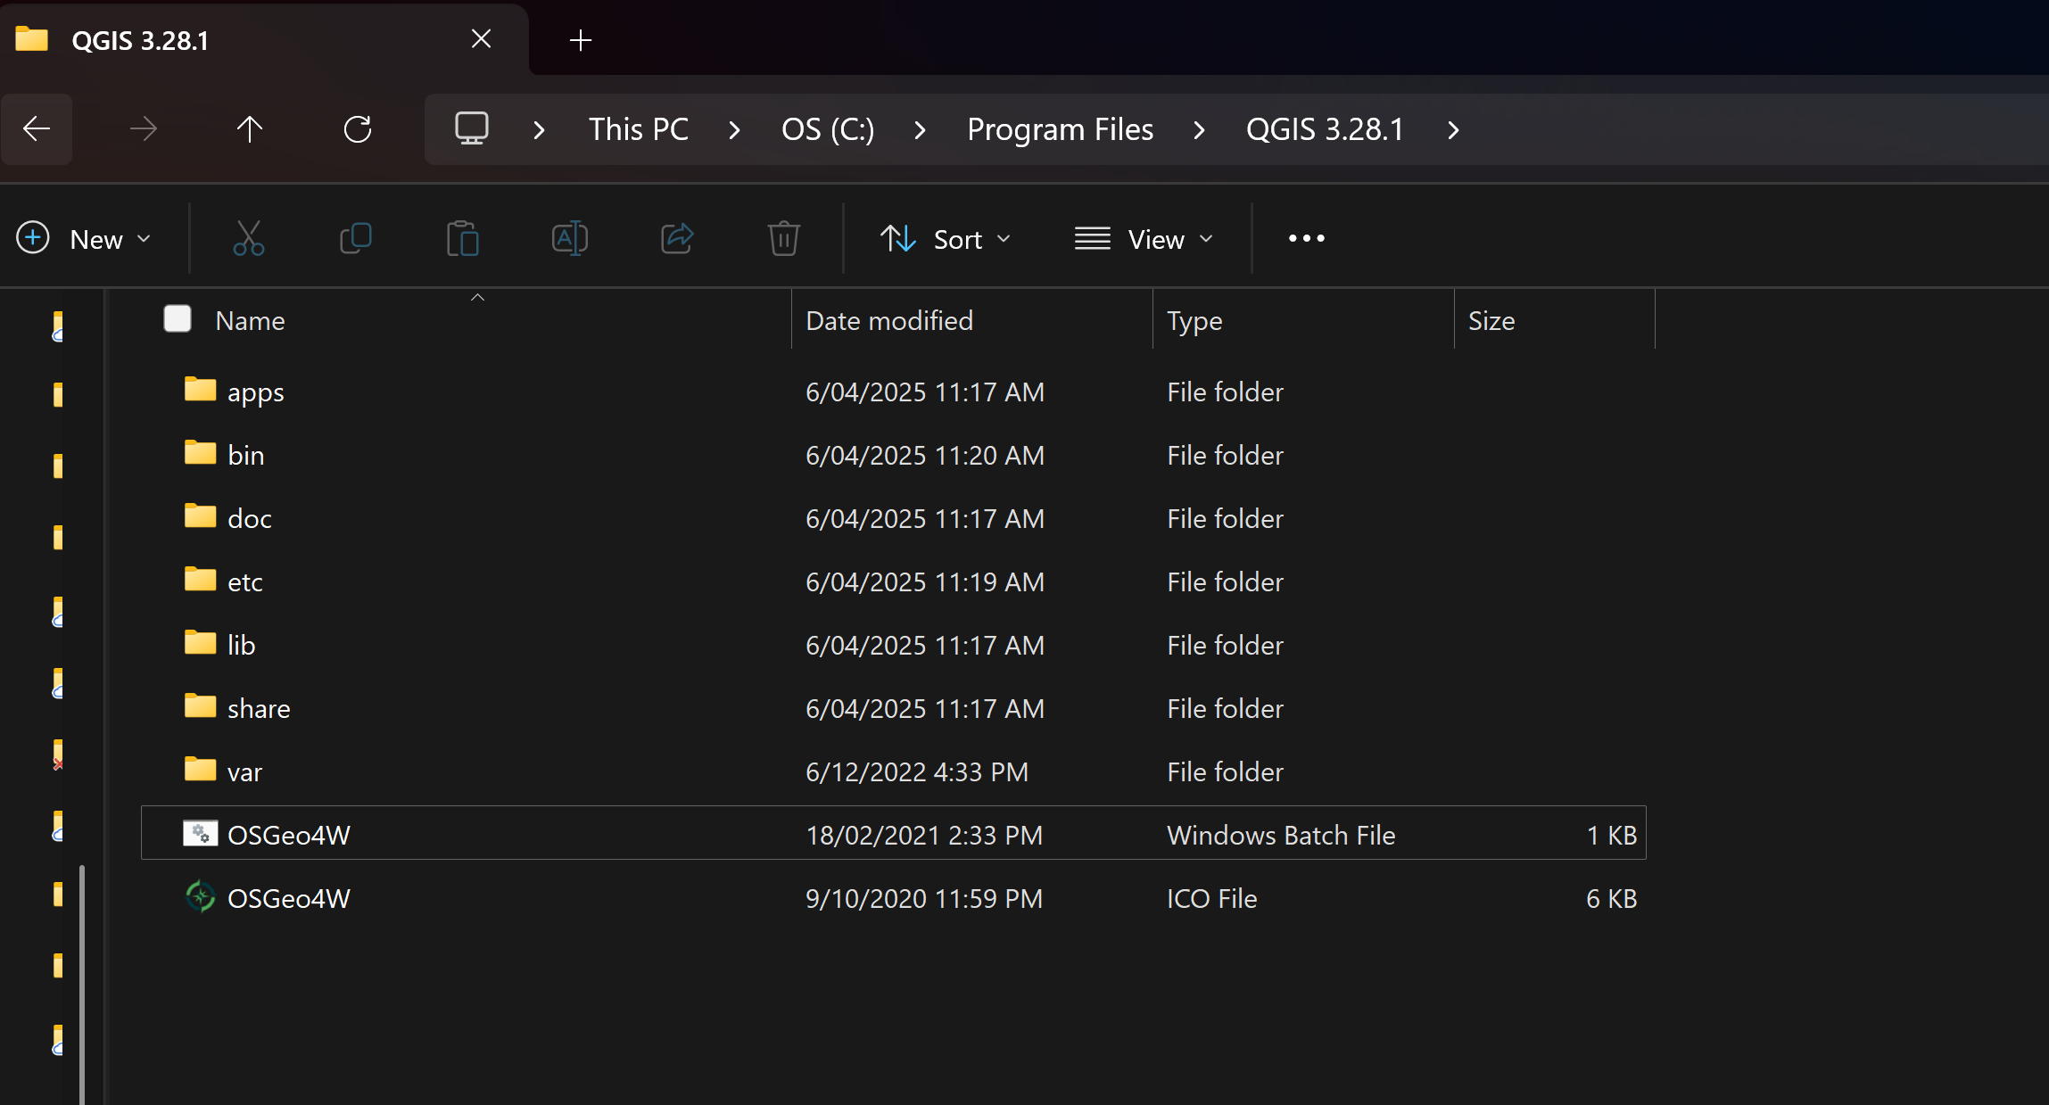



pip install loopstructural loopstructuralvisualisation pyvistaqt geoh5py

